**WEEK- 6**

**1.Create a new React Application with the name “myfirstreact”, Run the application to print “welcome to the first session of React” as heading of that page.**

**Define SPA and its benefits:** A Single-Page Application (SPA) loads a single HTML page and dynamically updates content, improving speed and user experience.

**Define React and identify its working**: React is a JavaScript library for building UI using reusable components and a virtual DOM for efficient rendering.

**Identify the differences between SPA and MPA:** SPA loads content dynamically on a single page, while MPA loads separate pages from the server for each request.

**Explain Pros & Cons of Single-Page Application**: Pros include faster navigation and better UX; cons include SEO limitations and initial load time.

**Explain about React:** React is a component-based JavaScript library that efficiently updates and renders user interfaces using a virtual DOM.

**Define virtual DOM:** Virtual DOM is a lightweight copy of the real DOM that React uses to track changes and update the UI efficiently.

**Explain Features of React:** React features include virtual DOM, component-based architecture, JSX syntax, unidirectional data flow, and performance optimization.

**APP.js**

import React from 'react';

function App() {

return (

<div style={{ display: 'flex', justifyContent: 'center', alignItems: 'center', height: '100vh' }}>

<h1>Welcome to the first session of React</h1>

</div>

);

}

export default App;

**App.test.js**

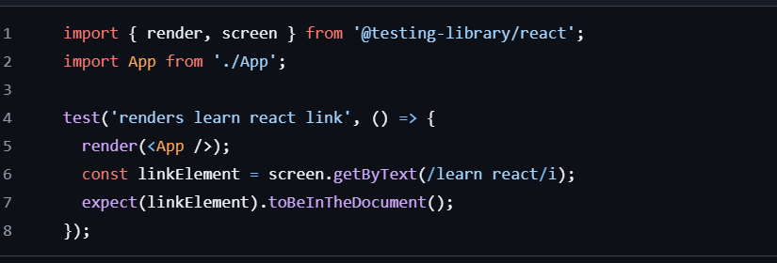

OUTPUT

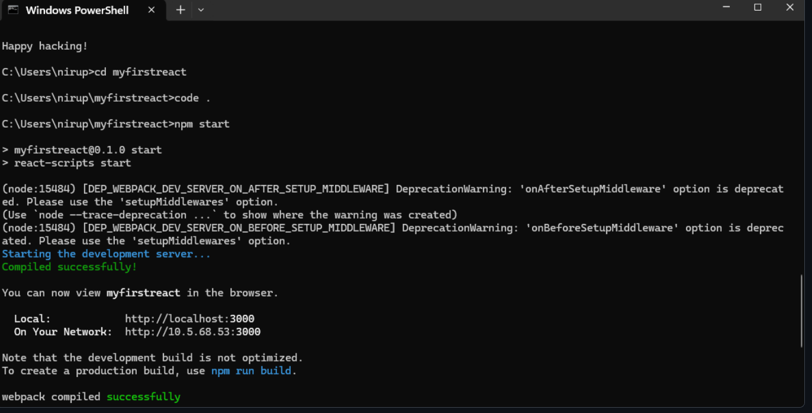

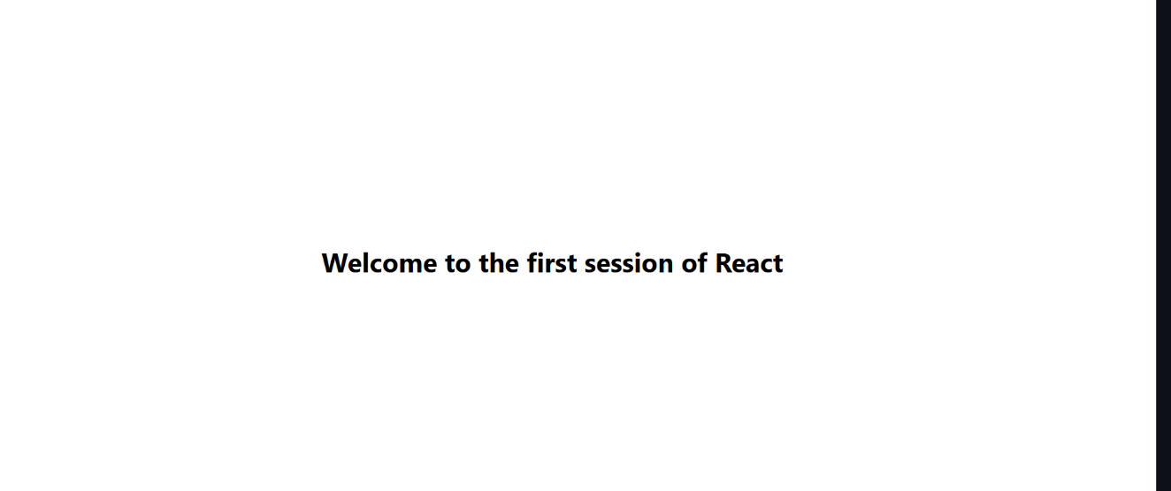

**2.Create a react app for Student Management Portal named StudentApp and create a component named Home which will display the Message “Welcome to the Home page of Student Management Portal”. Create another component named About and display the Message “Welcome to the About page of the Student Management Portal”. Create a third component named Contact and display the Message “Welcome to the Contact page of the Student Management Portal”.**

Explain React components: React components are reusable, self-contained blocks of UI that manage their own structure and behavior.

Identify the differences between components and JavaScript functions: React components return JSX for UI rendering, while regular JavaScript functions do not manage UI or lifecycle.

Identify the types of components: The two main types are class components and function components.

Explain class component: A class component is a React component defined using ES6 classes that can hold state and lifecycle methods.

Explain function component: A function component is a simpler component defined as a function that returns JSX and can use hooks for state and effects.

Define component constructor: The constructor is a method in class components used to initialize state and bind methods.

Define render() function: The render() function in class components returns the JSX to be displayed on the UI.

App.js

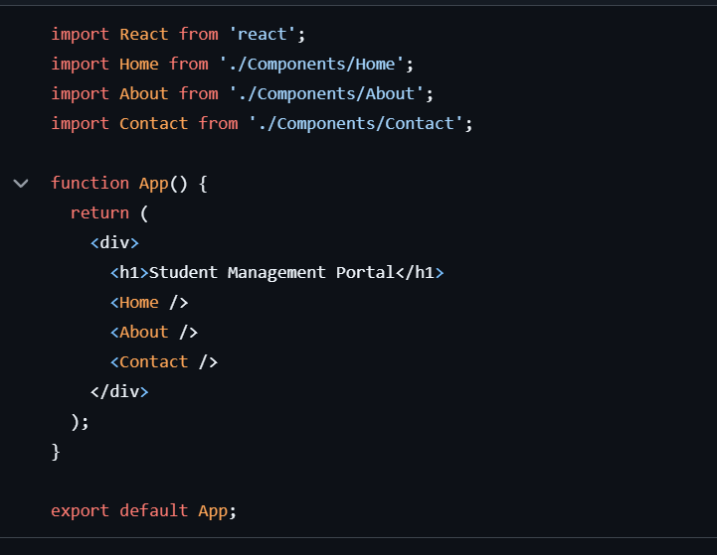

OUTPUT

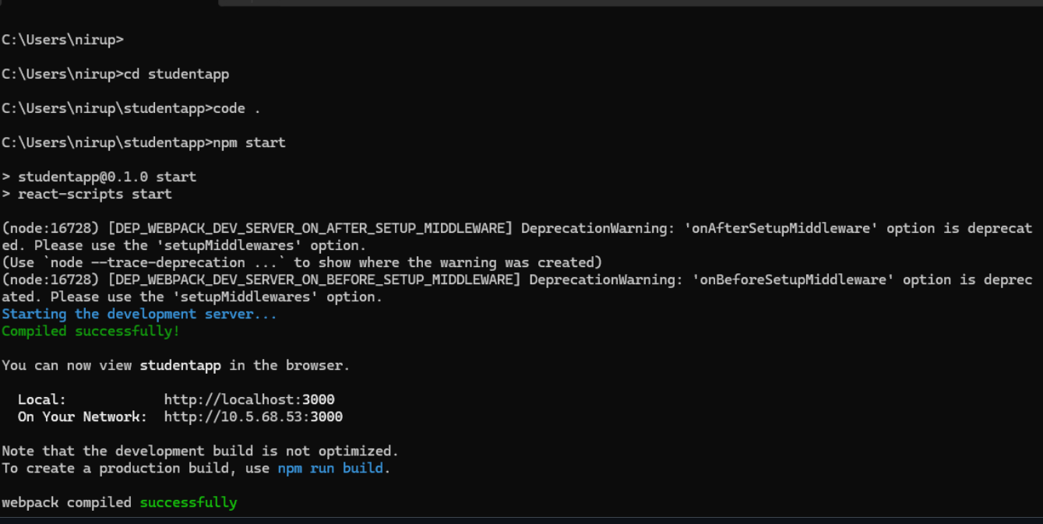

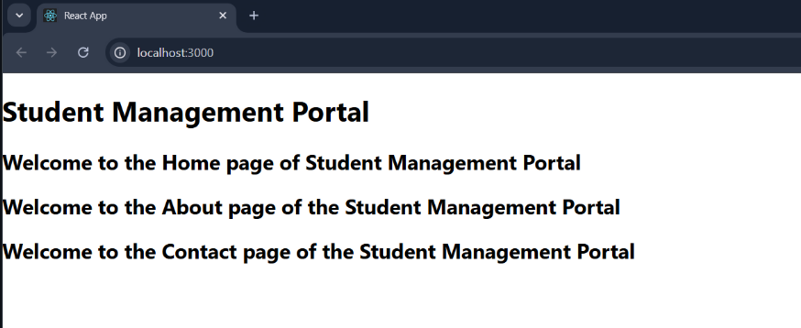

**3.Create a react app for Student Management Portal named scorecalculatorapp and create a function component named “CalculateScore” which will accept Name, School, Total and goal in order to calculate the average score of a student and display the same.**

App.js

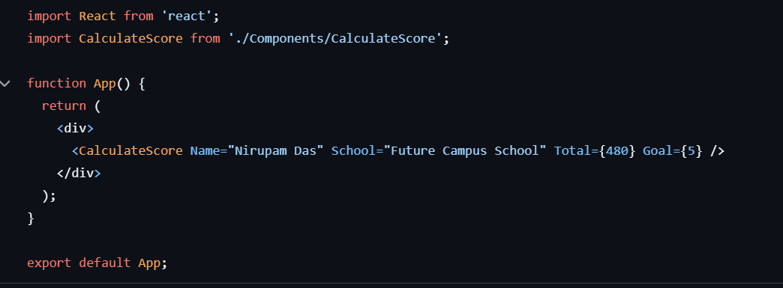

OUTPUT

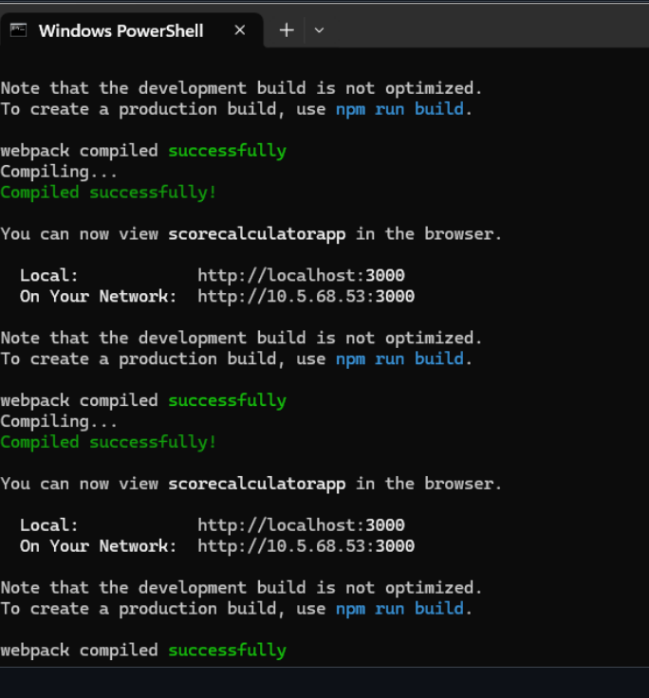

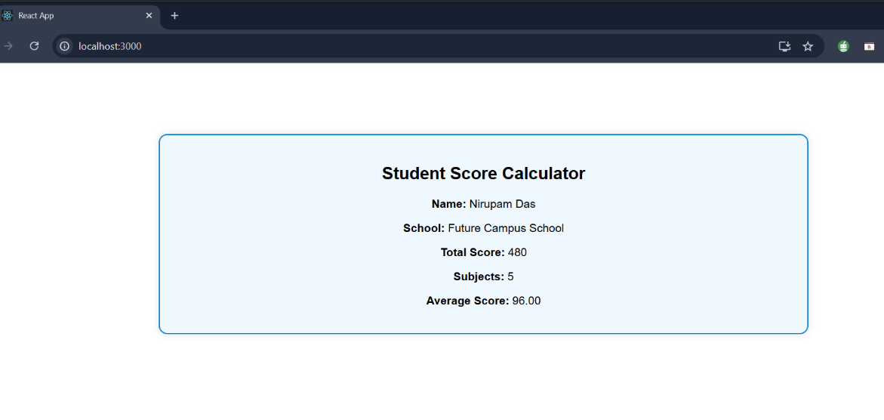

**4.**

**Create a new react application using *create-react-app* tool with the name as “blogapp”**

**Open the application using VS Code**

**Create a new file named as Post.js in src folder with following properties**

**Ans:**

**Explain the need and Benefits of component life cycle:** The component lifecycle helps manage and optimize resource usage, data fetching, and UI updates at specific stages.

**Identify various life cycle hook methods**: Key lifecycle methods include constructor(), render(), componentDidMount(), componentDidUpdate(), and componentWillUnmount().

**List the sequence of steps in rendering a component:** The typical sequence is: constructor() → render() → componentDidMount() → (updates) componentDidUpdate() → (removal) componentWillUnmount().

App.js

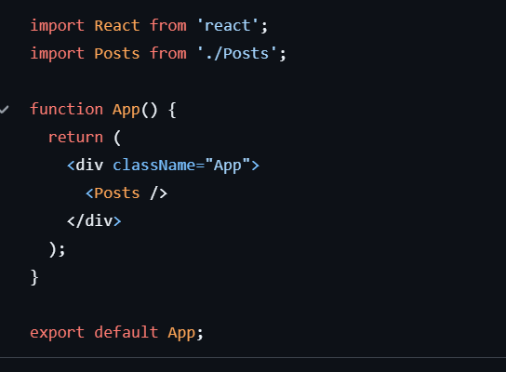

OUTPUT

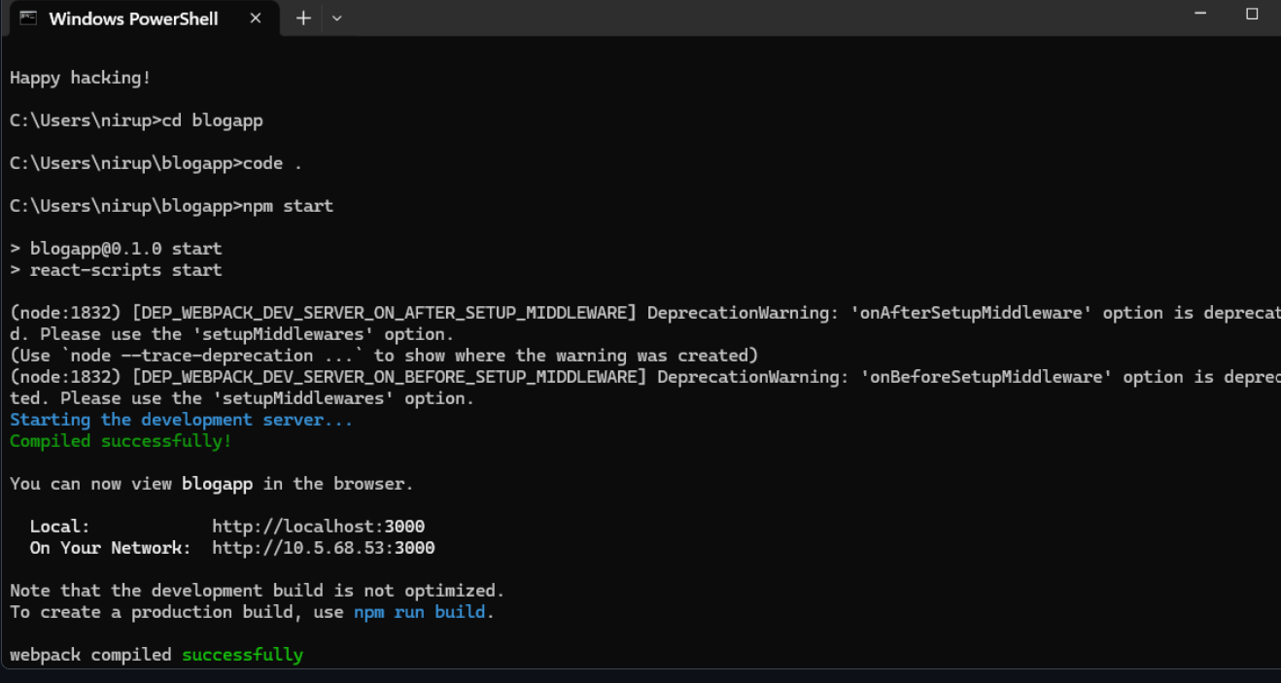

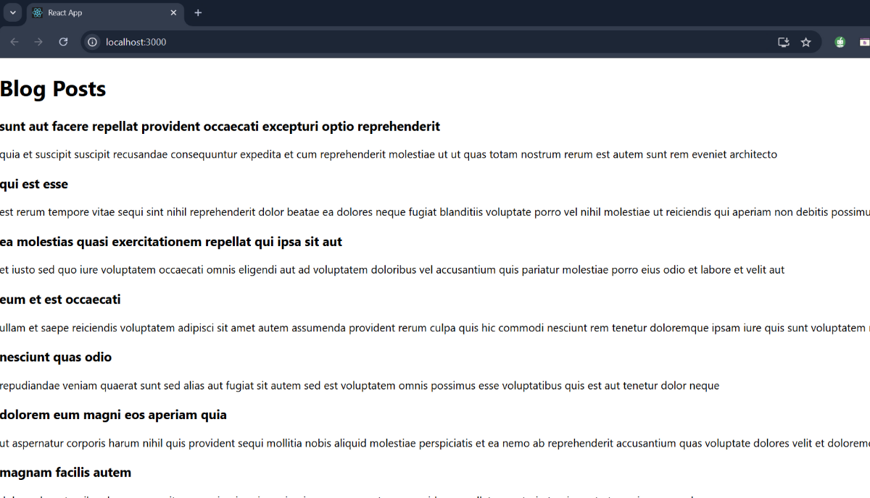

**5.My Academy team at Cognizant want to create a dashboard containing the details of ongoing and completed cohorts. A react application is created which displays the detail of the cohorts using react component. You are assigned the task of styling these react components.**

**Download and build the attached react application.**

**Ans:**

* Understanding the need for styling React component: Styling in React enhances UI appearance, ensures component-specific design, and improves user experience.
* Working with CSS Module and inline styles: CSS Modules provide scoped styling to components, while inline styles apply styles directly via the style attribute in JSX.

App.js

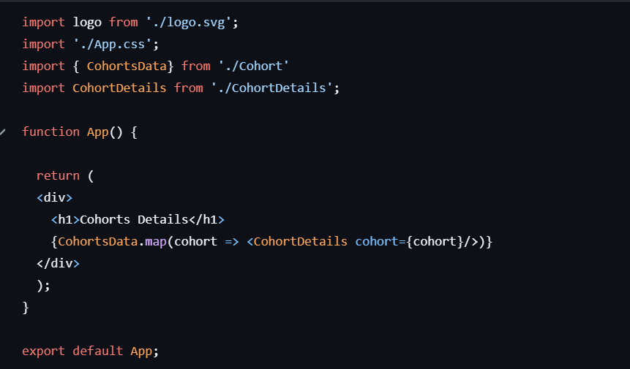

OUTPUT

